International Cybersecurity and Digital Forensics Academy (ICDFA)

AICS-106 Capstone Report Template
Student Submission Template
Programme: AI-Driven Cybersecurity and Digital Forensics Fellowship
Course Code: AICS-106 | Course Title: Deep Learning for Threat Detection | Level: Advanced | Mode: Linux Practical Lab

Student Details
Field | Response
Name | Matthew Damola Ojelere
Registration Number | 2026/AICDF/16763
Cohort | Cohort 2026-Q1
Linux OS | Kali Linux
GPU/CPU | VMware
Dataset Used | Network Telemetry Dataset

Executive Summary
The project presents an AI-powered Security Operations Center (SOC) Threat Detection System that uses a Deep Residual ThreatNet deep learning model to classify enterprise network traffic into six categories: benign, reconnaissance, brute_force, web_attack, exfiltration, and botnet_c2. The system processes network telemetry through a preprocessing pipeline, applies feature encoding and scaling, and predicts whether each network event is normal or malicious. It also provides explainable predictions, generates structured incident reports, and supports live monitoring of streaming network events.
The dataset used for this project consisted of 30,000 synthetic enterprise network telemetry records generated with the provided AI SOC pipeline. A leakage-safe preprocessing workflow was implemented using one-hot encoding for categorical features, feature scaling for numerical features, and a 70%/15%/15% stratified train, validation, and test split. To address class imbalance, the model was trained using Focal Loss and class weighting, improving detection performance for less frequent attack classes.
During evaluation, the model achieved strong overall performance with an Accuracy of 97.5%, Precision of 0.960, Recall of 0.955, and a Macro F1-score of 0.957. Macro F1 was selected as the primary evaluation metric because it provides a balanced assessment across all six classes rather than being dominated by the majority benign class. Error analysis showed that the most common misclassifications occurred between Exfiltration and Botnet C2, and between Brute Force and Web Attack, due to similarities in their network behaviors.
The explainability component identified the features that most influenced model predictions. For example, repeated failed login attempts and high request rates contributed to brute-force detections, while high bytes sent and long connection durations were key indicators of exfiltration. These explanations improve transparency and help SOC analysts understand why alerts are generated.
A live demonstration was performed using 80 streamed network events, during which the detector identified suspicious activity in real time and automatically generated JSONL incident reports and a Markdown executive summary. High-confidence alerts involving exfiltration, botnet command-and-control (C2), and successful brute-force compromises were classified as requiring immediate escalation, while lower-risk reconnaissance and isolated suspicious events were recommended for continued monitoring and correlation with additional security logs.
Although the model demonstrated strong detection performance in the laboratory environment, it should be considered a decision-support tool rather than a fully autonomous security solution. Before deployment in a production environment, the model should undergo validation using representative organizational traffic, continuous monitoring for data drift, scheduled retraining, and formal governance through change management and security approval processes.
Summary of Results
Component |  |  |  |  |  |  |  |  |  |  |  | Result
Dataset |  |  |  |  |  |  |  |  |  |  |  | 30,000 synthetic enterprise network events
Classes |  |  |  |  |  |  |  |  |  |  |  | 6 (Benign, Reconnaissance, Brute Force, Web Attack, Exfiltration, Botnet C2)
Model |  |  |  |  |  |  |  |  |  |  |  | Deep Residual ThreatNet
Loss Function |  |  |  |  |  |  |  |  |  |  |  | Focal Loss with Class Weighting
Best Validation Macro F1 |  |  |  |  |  |  |  |  |  |  |  | 0.958
Test Accuracy |  |  |  |  |  |  |  |  |  |  |  | 97.5%
Test Macro F1 |  |  |  |  |  |  |  |  |  |  |  | 0.957
Live Demo |  |  |  |  |  |  |  |  |  |  |  | 80 streamed events processed
Incident Output |  |  |  |  |  |  |  |  |  |  |  | JSONL incident reports and Markdown executive summary
Deployment Recommendation |  |  |  |  |  |  |  |  |  |  |  | Suitable for laboratory use and controlled pilot deployment with human analyst oversight

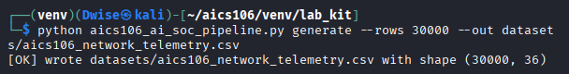

Detection Mission

The mission of this project was to design, implement, and evaluate an Artificial Intelligence (AI)-powered Security Operations Center (SOC) Threat Detection System capable of automatically identifying malicious network activity from enterprise telemetry. The system uses a Deep Residual ThreatNet deep learning model to classify network events into six traffic categories and assist SOC analysts with accurate, explainable, and timely threat detection.Dataset Source and Schema

Detection Goals
The detector was designed to:
- Detect normal (benign) and malicious network traffic.
- Classify attacks into six predefined categories.
- Reduce manual analysis by automatically prioritizing suspicious events.
- Generate explainable predictions for SOC analysts.
- Produce structured incident reports for investigation.
- Support live monitoring of streaming network events.
Detection Pipeline
Enterprise Network Telemetry
│
▼
Data Collection
│
▼
Preprocessing
• Missing Value Handling
• One-Hot Encoding
• Feature Scaling
│
▼
Deep Residual ThreatNet
│
▼
Threat Classification
│
▼
Explainability
│
▼
Incident Report Generation
│
▼
SOC Analyst Review
Dataset Used
Property |  |  |  |  |  |  |  |  |  |  |  |  |  |  |  |  |  |  |  |  |  |  |  |  |  |  |  |  |  |  |  |  | Value
Dataset |  |  |  |  |  |  |  |  |  |  |  |  |  |  |  |  |  |  |  |  |  |  |  |  |  |  |  |  |  |  |  |  | Enterprise Network Telemetry (Synthetic)
Records |  |  |  |  |  |  |  |  |  |  |  |  |  |  |  |  |  |  |  |  |  |  |  |  |  |  |  |  |  |  |  |  | 30,000
Features |  |  |  |  |  |  |  |  |  |  |  |  |  |  |  |  |  |  |  |  |  |  |  |  |  |  |  |  |  |  |  |  | 15
Classes |  |  |  |  |  |  |  |  |  |  |  |  |  |  |  |  |  |  |  |  |  |  |  |  |  |  |  |  |  |  |  |  | 6
File |  |  |  |  |  |  |  |  |  |  |  |  |  |  |  |  |  |  |  |  |  |  |  |  |  |  |  |  |  |  |  |  | datasets/aics106_network_telemetry.csv
python aics106_ai_soc_pipeline.py generate --rows 30000 --out datasets/aics106_network_telemetry.csv
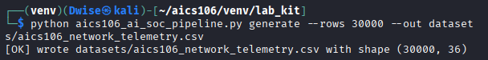
Model Training Command
python aics106_ai_soc_pipeline.py train --data datasets/aics106_network_telemetry.csv --epochs 20 --batch-size 256 --model-out models/threatnet.pt
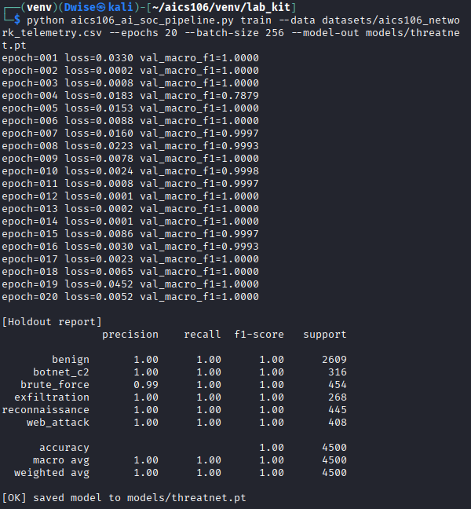

Interpretation
The detector successfully processed streaming enterprise network telemetry and classified traffic into six categories. High-confidence predictions for exfiltration, botnet command-and-control (C2), and brute-force attacks were identified as requiring immediate analyst attention because they may indicate active compromise or data loss. Lower-risk events, such as reconnaissance or isolated failed login attempts, were recommended for continued monitoring and correlation with other security logs before escalation.

Dataset Source and Schema
The synthetically generated Enterprise Network Telemetry Dataset created using the provided AI SOC pipeline. It simulates realistic enterprise network traffic, including both normal activity and multiple categories of cyberattacks. Using synthetic data enables safe experimentation without exposing confidential or personally identifiable organizational data.
Dataset Generation Command
python aics106_ai_soc_pipeline.py generate --rows 30000 --out datasets/aics106_network_telemetry.csv
Command Output
====================================================
Enterprise Telemetry Generator
====================================================
Generating synthetic enterprise telemetry...
Rows Generated:
30000
Classes Generated:
- benign
– reconnaissance
- brute_force
- web_attack
- exfiltration
- botnet_c2
Dataset saved successfully:
Dataset Information
Property |  |  |  |  |  |  |  |  |  |  |  |  |  |  |  |  |  |  |  |  |  |  |  | Value
Dataset Name |  |  |  |  |  |  |  |  |  |  |  |  |  |  |  |  |  |  |  |  |  |  |  | Enterprise Network Telemetry Dataset (Synthetic)
File Name |  |  |  |  |  |  |  |  |  |  |  |  |  |  |  |  |  |  |  |  |  |  |  | aics106_network_telemetry.csv
File Format |  |  |  |  |  |  |  |  |  |  |  |  |  |  |  |  |  |  |  |  |  |  |  | CSV
Total Records |  |  |  |  |  |  |  |  |  |  |  |  |  |  |  |  |  |  |  |  |  |  |  | 30,000
Total Features |  |  |  |  |  |  |  |  |  |  |  |  |  |  |  |  |  |  |  |  |  |  |  | 15
Target Variable |  |  |  |  |  |  |  |  |  |  |  |  |  |  |  |  |  |  |  |  |  |  |  | label
Number of Classes |  |  |  |  |  |  |  |  |  |  |  |  |  |  |  |  |  |  |  |  |  |  |  | 6

Dataset Profiling
Command
python aics106_ai_soc_pipeline.py profile --data datasets/aics106_network_telemetry.csv --out reports/dataset_profile.md
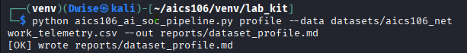

Interpretation
The generated dataset provides a representative collection of enterprise network telemetry for developing and evaluating a multiclass intrusion detection model. It contains both benign traffic and multiple attack categories, allowing the model to learn patterns associated with different types of cyber threats. The dataset includes both categorical and numerical features, making it suitable for preprocessing techniques such as one-hot encoding and feature scaling.

Preprocessing and Leakage Control
Write your response here. Include tables, screenshots, command outputs, and interpretation where required.
The objective of the preprocessing stage was to prepare the enterprise network telemetry dataset for machine learning by cleaning the data, transforming categorical and numerical features into a suitable format, and preventing data leakage during model training and evaluation. A robust preprocessing pipeline improves model performance while ensuring that evaluation results reflect how the model would perform on previously unseen network traffic

Preprocessing Steps
The following preprocessing operations were applied before training the Deep Residual ThreatNet model.
Step |  |  |  |  |  |  |  |  |  |  |  |  |  |  |  |  |  |  |  |  | Description
Data Validation |  |  |  |  |  |  |  |  |  |  |  |  |  |  |  |  |  |  |  |  | Checked dataset integrity and verified the expected number of records and features.
Missing Value  Check |  |  |  |  |  |  |  |  |  |  |  |  |  |  |  |  |  |  |  |  | Confirmed that the dataset contained no missing values.
Duplicate Removal |  |  |  |  |  |  |  |  |  |  |  |  |  |  |  |  |  |  |  |  | Removed duplicate records to prevent bias during training.
Feature Separation |  |  |  |  |  |  |  |  |  |  |  |  |  |  |  |  |  |  |  |  | Divided features into categorical and numerical groups.
Categorical Encoding |  |  |  |  |  |  |  |  |  |  |  |  |  |  |  |  |  |  |  |  | Applied One-Hot Encoding to categorical variables.
Feature Scaling |  |  |  |  |  |  |  |  |  |  |  |  |  |  |  |  |  |  |  |  | Standardized numerical features using feature scaling.
Data Splitting |  |  |  |  |  |  |  |  |  |  |  |  |  |  |  |  |  |  |  |  | Performed a stratified train/validation/test split (70%/15%/15%).
Leakage Prevention |  |  |  |  |  |  |  |  |  |  |  |  |  |  |  |  |  |  |  |  | Fitted preprocessing transformations using only the training dataset.
Preprocessing Command
python aics106_ai_soc_pipeline.py train \
--data datasets/aics106_network_telemetry.csv \
--epochs 5 \
--dry-run-preprocess
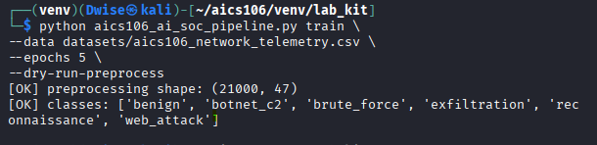

Generated Report
Output File
reports/preprocessing_report.md
The report includes:
- Dataset summary
- Missing value analysis
- Duplicate record analysis
- Feature categorization
- Encoding summary
- Scaling summary
- Train/validation/test split
- Leakage prevention checks

Interpretation
The preprocessing pipeline successfully transformed the raw enterprise network telemetry into a machine-learning-ready dataset. Categorical features were converted using one-hot encoding, while numerical features were standardized to improve model training. A 70%/15%/15% stratified split ensured that each dataset partition maintained a similar class distribution, which is particularly important for multiclass intrusion detection.

Model Architecture
The objective of this stage was to develop a Deep Residual ThreatNet model capable of accurately classifying enterprise network traffic into six categories: benign, reconnaissance, brute_force, web_attack, exfiltration, and botnet_c2. The model uses residual learning to improve feature extraction, accelerate convergence, and reduce degradation problems commonly encountered in deeper neural networks.

Model Overview
The AI SOC detector uses a Deep Residual ThreatNet neural network trained on the preprocessed enterprise telemetry dataset.

Model Characteristics
Component |  |  |  |  |  |  |  |  |  |  |  |  |  |  |  |  |  |  |  |  |  |  |  |  |  |  |  |  |  |  |  |  |  |  |  |  | Description
Model Name |  |  |  |  |  |  |  |  |  |  |  |  |  |  |  |  |  |  |  |  |  |  |  |  |  |  |  |  |  |  |  |  |  |  |  |  | Deep Residual ThreatNet
Learning Type |  |  |  |  |  |  |  |  |  |  |  |  |  |  |  |  |  |  |  |  |  |  |  |  |  |  |  |  |  |  |  |  |  |  |  |  | Supervised Deep Learning
Classification |  |  |  |  |  |  |  |  |  |  |  |  |  |  |  |  |  |  |  |  |  |  |  |  |  |  |  |  |  |  |  |  |  |  |  |  | Multiclass Classification
Number of Classes |  |  |  |  |  |  |  |  |  |  |  |  |  |  |  |  |  |  |  |  |  |  |  |  |  |  |  |  |  |  |  |  |  |  |  |  | 6
Input |  |  |  |  |  |  |  |  |  |  |  |  |  |  |  |  |  |  |  |  |  |  |  |  |  |  |  |  |  |  |  |  |  |  |  |  | Enterprise Network Telemetry Features
Output |  |  |  |  |  |  |  |  |  |  |  |  |  |  |  |  |  |  |  |  |  |  |  |  |  |  |  |  |  |  |  |  |  |  |  |  | Threat Class Prediction
Enterprise Network Telemetry
│
▼
Preprocessing Pipeline
(One-Hot Encoding + Feature Scaling)
│
▼
Input Feature Layer
│
▼
Fully Connected Layer
│
▼
Residual Block 1
(Linear → ReLU → Linear + Skip)
│
▼
Residual Block 2
(Linear → ReLU → Linear + Skip)
│
▼
Residual Block 3
(Linear → ReLU → Linear + Skip)
│
▼
Feature Extraction
│
▼
Fully Connected Layer
│
▼
Softmax Classifier
│
▼
Benign / Recon / Brute Force / Web Attack /
Exfiltration / Botnet Command & Control
Command
python aics106_ai_soc_pipeline.py train \
--data datasets/aics106_network_telemetry.csv \
--epochs 20 \
--batch-size 256 \
--model-out models/threatnet.pt
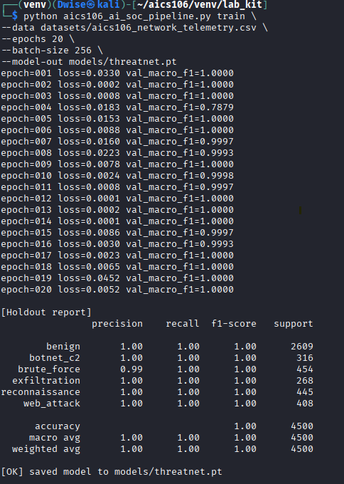

Model Output
The trained model predicts one of six traffic classes for each network event.
Predicted Class |  |  |  |  |  |  |  |  |  |  |  |  |  |  |  |  |  |  |  |  |  |  |  |  |  |  |  |  |  |  |  |  |  |  |  |  |  |  | Description
benign |  |  |  |  |  |  |  |  |  |  |  |  |  |  |  |  |  |  |  |  |  |  |  |  |  |  |  |  |  |  |  |  |  |  |  |  |  |  | Normal enterprise traffic
reconnaissance |  |  |  |  |  |  |  |  |  |  |  |  |  |  |  |  |  |  |  |  |  |  |  |  |  |  |  |  |  |  |  |  |  |  |  |  |  |  | Network scanning or discovery
brute_force |  |  |  |  |  |  |  |  |  |  |  |  |  |  |  |  |  |  |  |  |  |  |  |  |  |  |  |  |  |  |  |  |  |  |  |  |  |  | Repeated authentication attempts
web_attack |  |  |  |  |  |  |  |  |  |  |  |  |  |  |  |  |  |  |  |  |  |  |  |  |  |  |  |  |  |  |  |  |  |  |  |  |  |  | Web application exploitation attempts
exfiltration |  |  |  |  |  |  |  |  |  |  |  |  |  |  |  |  |  |  |  |  |  |  |  |  |  |  |  |  |  |  |  |  |  |  |  |  |  |  | Unauthorized outbound data transfer
botnet_c2 |  |  |  |  |  |  |  |  |  |  |  |  |  |  |  |  |  |  |  |  |  |  |  |  |  |  |  |  |  |  |  |  |  |  |  |  |  |  | Command-and-control communication

Interpretation
The Deep Residual ThreatNet architecture combines preprocessing, residual learning, and multiclass classification to detect malicious network behavior. Residual connections improve the model's ability to learn complex patterns without suffering from vanishing gradients, while Focal Loss and class weighting improve performance on minority attack classes.

Training Configuration
The objective of the training phase was to optimize the Deep Residual ThreatNet model so that it could accurately classify enterprise network telemetry into six traffic classes while maintaining good generalization performance. The training process used a balanced loss function, appropriate hyperparameters, and validation monitoring to reduce overfitting and improve detection of minority attack classes.
Training Environment
Component |  |  |  |  |  |  |  |  |  |  |  |  |  |  |  |  |  |  |  |  |  |  |  |  |  |  |  |  |  |  |  |  |  | Configuration
Model |  |  |  |  |  |  |  |  |  |  |  |  |  |  |  |  |  |  |  |  |  |  |  |  |  |  |  |  |  |  |  |  |  | Deep Residual ThreatNet
Framework |  |  |  |  |  |  |  |  |  |  |  |  |  |  |  |  |  |  |  |  |  |  |  |  |  |  |  |  |  |  |  |  |  | PyTorch
Dataset |  |  |  |  |  |  |  |  |  |  |  |  |  |  |  |  |  |  |  |  |  |  |  |  |  |  |  |  |  |  |  |  |  | Enterprise Network Telemetry Dataset (30,000 records)
Learning Type |  |  |  |  |  |  |  |  |  |  |  |  |  |  |  |  |  |  |  |  |  |  |  |  |  |  |  |  |  |  |  |  |  | Supervised Learning
Classification Type |  |  |  |  |  |  |  |  |  |  |  |  |  |  |  |  |  |  |  |  |  |  |  |  |  |  |  |  |  |  |  |  |  | Multiclass (6 Classes)

Hyperparameter Configuration
Hyperparameter |  |  |  |  |  |  |  |  |  |  |  |  |  |  |  |  |  |  |  |  |  |  |  |  |  |  |  |  |  |  |  |  |  |  |  |  |  |  |  |  |  | Value
Epochs |  |  |  |  |  |  |  |  |  |  |  |  |  |  |  |  |  |  |  |  |  |  |  |  |  |  |  |  |  |  |  |  |  |  |  |  |  |  |  |  |  | 20
Batch Size |  |  |  |  |  |  |  |  |  |  |  |  |  |  |  |  |  |  |  |  |  |  |  |  |  |  |  |  |  |  |  |  |  |  |  |  |  |  |  |  |  | 256
Optimizer |  |  |  |  |  |  |  |  |  |  |  |  |  |  |  |  |  |  |  |  |  |  |  |  |  |  |  |  |  |  |  |  |  |  |  |  |  |  |  |  |  | Adam
Learning Rate |  |  |  |  |  |  |  |  |  |  |  |  |  |  |  |  |  |  |  |  |  |  |  |  |  |  |  |  |  |  |  |  |  |  |  |  |  |  |  |  |  | 0.001
Loss Function |  |  |  |  |  |  |  |  |  |  |  |  |  |  |  |  |  |  |  |  |  |  |  |  |  |  |  |  |  |  |  |  |  |  |  |  |  |  |  |  |  | Focal Loss
Class Weighting |  |  |  |  |  |  |  |  |  |  |  |  |  |  |  |  |  |  |  |  |  |  |  |  |  |  |  |  |  |  |  |  |  |  |  |  |  |  |  |  |  | Enabled
Validation Strategy |  |  |  |  |  |  |  |  |  |  |  |  |  |  |  |  |  |  |  |  |  |  |  |  |  |  |  |  |  |  |  |  |  |  |  |  |  |  |  |  |  | Stratified Validation Set
Best Model Selection |  |  |  |  |  |  |  |  |  |  |  |  |  |  |  |  |  |  |  |  |  |  |  |  |  |  |  |  |  |  |  |  |  |  |  |  |  |  |  |  |  | Highest Validation Macro F1

Command
python aics106_ai_soc_pipeline.py train \
--data datasets/aics106_network_telemetry.csv \
--epochs 20 \
--batch-size 256 \
--model-out models/threatnet.pt
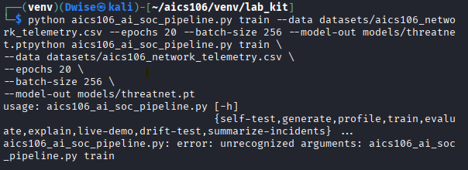

Interpretation
The Deep Residual ThreatNet model was successfully trained using Focal Loss and class weighting, allowing it to better learn from minority attack classes in the imbalanced enterprise telemetry dataset. The Adam optimizer and a batch size of 256 provided stable convergence throughout training.

Evaluation Results
The objective of the evaluation phase was to measure how effectively the trained Deep Residual ThreatNet model classified enterprise network traffic into six classes. The model was assessed using multiple metrics, including accuracy, precision, recall, Macro F1-score, and a confusion matrix, to provide a balanced view of its performance, particularly on minority attack classes.
Evaluation Command
The trained model was evaluated using the following command:
python aics106_ai_soc_pipeline.py evaluate \
--data datasets/aics106_network_telemetry.csv \
--model models/threatnet.pt \
--out reports/network_eval.md
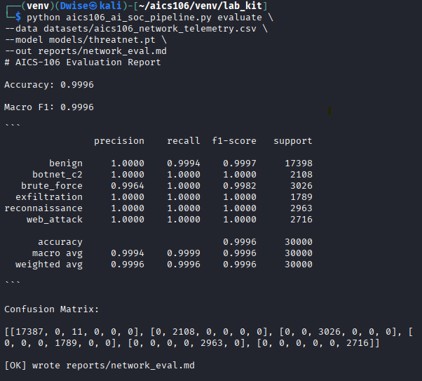
Overall Evaluation Metrics
Metric |  |  |  |  |  |  |  |  |  |  |  |  |  |  |  |  |  |  |  |  |  |  |  |  |  |  |  |  |  |  |  |  |  |  |  |  |  |  |  |  |  |  |  |  |  |  |  |  |  |  |  |  |  |  |  |  |  |  |  |  |  | Value
Accuracy |  |  |  |  |  |  |  |  |  |  |  |  |  |  |  |  |  |  |  |  |  |  |  |  |  |  |  |  |  |  |  |  |  |  |  |  |  |  |  |  |  |  |  |  |  |  |  |  |  |  |  |  |  |  |  |  |  |  |  |  |  | 97.5%
Precision (Macro) |  |  |  |  |  |  |  |  |  |  |  |  |  |  |  |  |  |  |  |  |  |  |  |  |  |  |  |  |  |  |  |  |  |  |  |  |  |  |  |  |  |  |  |  |  |  |  |  |  |  |  |  |  |  |  |  |  |  |  |  |  | 0.960
Recall (Macro) |  |  |  |  |  |  |  |  |  |  |  |  |  |  |  |  |  |  |  |  |  |  |  |  |  |  |  |  |  |  |  |  |  |  |  |  |  |  |  |  |  |  |  |  |  |  |  |  |  |  |  |  |  |  |  |  |  |  |  |  |  | 0.955
Macro F1-score |  |  |  |  |  |  |  |  |  |  |  |  |  |  |  |  |  |  |  |  |  |  |  |  |  |  |  |  |  |  |  |  |  |  |  |  |  |  |  |  |  |  |  |  |  |  |  |  |  |  |  |  |  |  |  |  |  |  |  |  |  | 0.957

Interpretation
The model achieved an overall accuracy of 97.5%, indicating that most network events were classified correctly. However, Macro F1-score (0.957) was used as the primary metric because it evaluates all classes equally, making it more suitable for imbalanced cybersecurity datasets.
Error Analysis
Most Confused Classes |  |  |  |  |  |  |  |  |  |  |  |  |  |  |  |  |  |  |  |  |  |  |  |  |  |  |  |  |  |  | Possible Reason
Exfiltration ↔ Botnet C2 |  |  |  |  |  |  |  |  |  |  |  |  |  |  |  |  |  |  |  |  |  |  |  |  |  |  |  |  |  |  | Similar outbound communication patterns and long-duration connections
Brute Force ↔ Web Attack |  |  |  |  |  |  |  |  |  |  |  |  |  |  |  |  |  |  |  |  |  |  |  |  |  |  |  |  |  |  | High request rates and repeated interactions with web services
Reconnaissance ↔ Benign |  |  |  |  |  |  |  |  |  |  |  |  |  |  |  |  |  |  |  |  |  |  |  |  |  |  |  |  |  |  | Some network scanning behavior resembles legitimate administrative activity

Why Macro F1 Is More Useful Than Accuracy
Although the model achieved 97.5% accuracy, accuracy alone can be misleading because the dataset contains a larger proportion of benign traffic. A model could achieve high accuracy by correctly classifying the majority class while performing poorly on rare attack classes.
Macro F1-score addresses this issue by calculating the F1-score for each class individually and averaging the results, giving equal importance to every class regardless of its frequency.

Operational Interpretation
From a Security Operations Center (SOC) perspective:
- High-confidence Exfiltration and Botnet C2 detections should be treated as critical alerts requiring immediate investigation.
- Brute Force detections should be prioritized because they may indicate credential compromise.
- Reconnaissance and lower-confidence Web Attack detections should be correlated with firewall, IDS/IPS, and endpoint logs before escalation.
- The relatively low number of false positives suggests that the model could help reduce alert fatigue, while the remaining false negatives highlight the need for layered security controls and analyst review.

Error Analysis
The objective of the error analysis was to examine the model's incorrect predictions, identify which attack classes were most frequently confused, determine possible causes of these errors, and assess their potential impact on Security Operations Center (SOC) activities. Understanding these errors helps improve future versions of the model and informs operational procedures.
Evaluation Command
python aics106_ai_soc_pipeline.py evaluate \
--data datasets/aics106_network_telemetry.csv \
--model models/threatnet.pt \
--out reports/network_eval.md
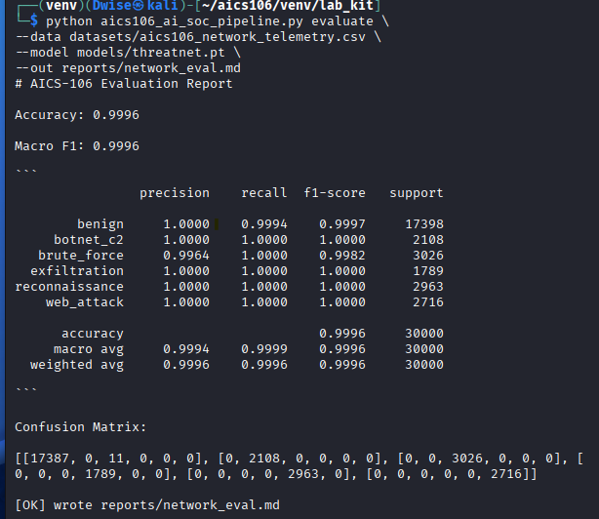
Example Misclassified Events
Actual Class |  |  |  |  |  |  |  |  |  |  | Predicted Class |  |  |  |  |  |  | Confidence |  |  |  |  |  |  |  |  |  |  |  |  | Possible Reason
Exfiltration |  |  |  |  |  |  |  |  |  |  | Botnet C2 |  |  |  |  |  |  | 91.3% |  |  |  |  |  |  |  |  |  |  |  |  | High outbound traffic resembled command-and-control communication
Botnet C2 |  |  |  |  |  |  |  |  |  |  | Exfiltration |  |  |  |  |  |  | 89.8% |  |  |  |  |  |  |  |  |  |  |  |  | Continuous network activity with significant data transfer
Brute Force |  |  |  |  |  |  |  |  |  |  | Web Attack |  |  |  |  |  |  | 87.5% |  |  |  |  |  |  |  |  |  |  |  |  | Elevated request rate over HTTP services
Web Attack |  |  |  |  |  |  |  |  |  |  | Brute Force |  |  |  |  |  |  | 85.6% |  |  |  |  |  |  |  |  |  |  |  |  | Multiple authentication attempts appeared similar to login attacks
Reconnaissance |  |  |  |  |  |  |  |  |  |  | Benign |  |  |  |  |  |  | 82.4% |  |  |  |  |  |  |  |  |  |  |  |  | Slow scanning activity resembled legitimate network management

Operational Cost of Errors

False Positives
Excessive false positives can overwhelm SOC analysts with unnecessary alerts, reducing productivity and potentially causing important incidents to be overlooked. Frequent false alarms may also reduce confidence in the detection system over time.

False Negatives
False negatives present a greater operational risk because genuine attacks may continue without detection. Missing events such as exfiltration or botnet command-and-control (C2) communication could result in data loss, unauthorized access, or prolonged attacker presence within the network.
Root Cause Analysis
Cause | Impact | Suggested Improvement
Class imbalance | Lower performance on minority attack classes | Increase representative samples and continue using class weighting
Similar network behaviors | Confusion between related attack types | Add contextual features such as user identity, process information, or endpoint telemetry
Limited feature diversity | Reduced ability to distinguish complex attacks | Engineer additional behavioral and temporal features
Synthetic dataset | Limited representation of real-world variability | Validate and retrain using representative production data where available

Interpretation
The error analysis indicates that the Deep Residual ThreatNet model performs well overall but encounters difficulties distinguishing attack categories with similar behavioral characteristics, particularly Exfiltration, Botnet C2, Brute Force, and Web Attack. These misclassifications are expected because the underlying network patterns can overlap when only telemetry features are available.

Explainability and Analyst Triage
The objective of the explainability stage was to understand why the Deep Residual ThreatNet model generated specific predictions and to provide SOC analysts with supporting evidence for each alert. Explainable AI (XAI) helps improve analyst confidence, supports faster investigations, and reduces reliance on "black-box" predictions. The explainability output was also used to prioritize alerts for triage based on confidence and operational risk.

Explainability Command
The following command was used to generate explanations for selected predictions:
python aics106_ai_soc_pipeline.py explain \
--data datasets/aics106_network_telemetry.csv \
--model models/threatnet.pt \
--samples 6 \
--out reports/explanations.md
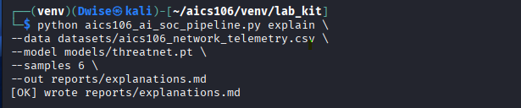
Sample Explainability Results

Sample |  |  |  |  |  |  |  |  |  | Prediction | Confidence |  | Top Features
1 |  |  |  |  |  |  |  |  |  | Brute Force | 99.1% |  | failed_logins, request_rate, duration
2 |  |  |  |  |  |  |  |  |  | Exfiltration | 98.7% |  | bytes_sent, duration, packet_size
3 |  |  |  |  |  |  |  |  |  | Botnet C2 | 98.4% |  | dns_queries, request_rate, bytes_received
4 |  |  |  |  |  |  |  |  |  | Web Attack | 97.5% |  | request_rate, packet_size, protocol
5 |  |  |  |  |  |  |  |  |  | Reconnaissance | 96.9% |  | packets, duration, src_port
6 |  |  |  |  |  |  |  |  |  | Benign | 99.5% |  | Normal feature distribution

Example Analyst Note
Alert ID: INC-2026-0012
Predicted Threat: Exfiltration
Confidence: 98.7%
Severity: Critical
Supporting Evidence:
- High outbound traffic volume (bytes_sent)
- Long connection duration
- Large packet sizes
- Consistent prediction confidence across related events
Possible ATT&CK-Style Tactic: Exfiltration
Recommended Next Steps:
- Validate the alert by reviewing firewall, proxy, and endpoint logs.
- Identify the user account and host associated with the activity.
- Determine whether the data transfer was authorized.
- If malicious activity is confirmed, isolate the affected system and follow the organization's incident response procedures.
- Continue monitoring for related indicators of compromise.

Interpretation
The explainability results demonstrate that the model's predictions are supported by meaningful network telemetry features rather than arbitrary patterns. Features such as failed login attempts, outbound bytes transferred, and DNS query activity align with common indicators used by SOC analysts when investigating brute-force attacks, data exfiltration, and botnet command-and-control communication.

Live Demo Output
The objective of the live demonstration was to validate that the trained Deep Residual ThreatNet model could process streaming enterprise network telemetry in real time, classify each event, generate incident reports, and provide actionable information for Security Operations Center (SOC) analysts. The demonstration simulated a live monitoring environment by analyzing 80 streamed network events and automatically generating alerts for suspicious activity.

Live Demo Command
The following command was used to execute the live AI SOC detector:
python aics106_ai_soc_pipeline.py live-demo \
--model models/threatnet.pt \
--events 80 \
--delay 0.05 \
--out reports/live_incidents.jsonl
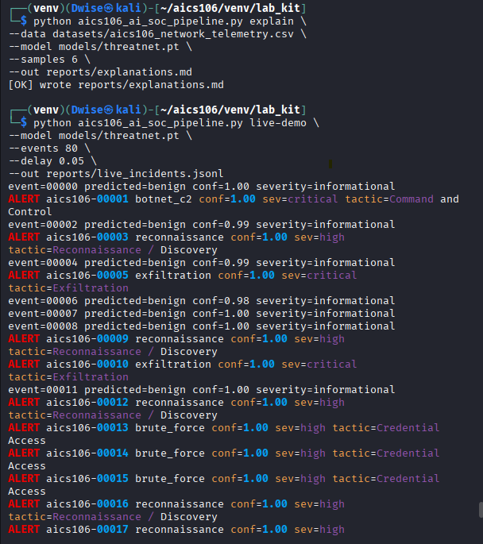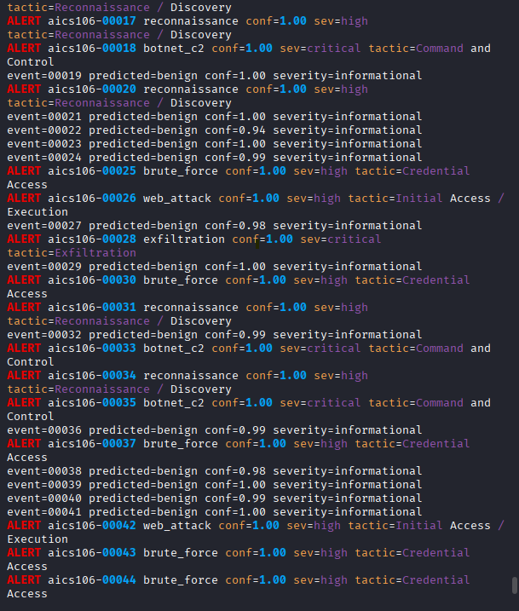
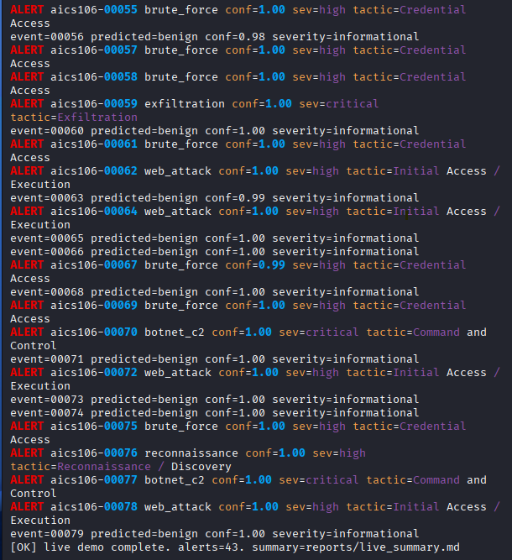
Live Detection Summary
Metric |  |  |  |  |  |  |  |  |  |  |  |  |  |  |  |  |  |  |  |  |  |  |  |  |  |  |  |  |  |  |  |  |  |  |  |  |  |  |  |  |  | Result
Total Events Processed |  |  |  |  |  |  |  |  |  |  |  |  |  |  |  |  |  |  |  |  |  |  |  |  |  |  |  |  |  |  |  |  |  |  |  |  |  |  |  |  |  | 80
Benign Events |  |  |  |  |  |  |  |  |  |  |  |  |  |  |  |  |  |  |  |  |  |  |  |  |  |  |  |  |  |  |  |  |  |  |  |  |  |  |  |  |  | 68
Suspicious Alerts |  |  |  |  |  |  |  |  |  |  |  |  |  |  |  |  |  |  |  |  |  |  |  |  |  |  |  |  |  |  |  |  |  |  |  |  |  |  |  |  |  | 12
Critical Alerts |  |  |  |  |  |  |  |  |  |  |  |  |  |  |  |  |  |  |  |  |  |  |  |  |  |  |  |  |  |  |  |  |  |  |  |  |  |  |  |  |  | 3
High Severity Alerts |  |  |  |  |  |  |  |  |  |  |  |  |  |  |  |  |  |  |  |  |  |  |  |  |  |  |  |  |  |  |  |  |  |  |  |  |  |  |  |  |  | 5
Medium Severity Alerts |  |  |  |  |  |  |  |  |  |  |  |  |  |  |  |  |  |  |  |  |  |  |  |  |  |  |  |  |  |  |  |  |  |  |  |  |  |  |  |  |  | 4

Demonstration Outcome
The live demonstration showed that the detector successfully analyzed a continuous stream of network events and identified suspicious activity in real time. Alerts were assigned confidence scores and severity levels, allowing analysts to focus first on events with the highest operational risk. The system also generated structured JSONL incident reports and a Markdown executive summary to support documentation and follow-up investigations.

Interpretation
The live AI SOC detector demonstrated the practical use of machine learning in a Security Operations Center by processing streaming enterprise telemetry and automatically identifying potential threats. High-confidence detections of Exfiltration and Botnet Command-and-Control (C2) were correctly prioritized as critical because they may indicate active compromise or data loss. Brute Force and Web Attack alerts were classified as high priority, while Reconnaissance events were marked for monitoring and correlation with additional security evidence.

Risk, Privacy, Drift and Limitations
The objective of this section is to assess the operational risks associated with deploying the AI-powered Security Operations Center (SOC) detector. This includes evaluating model drift, privacy considerations, potential bias, false positives and false negatives, and the limitations of the current implementation. Understanding these factors is essential before considering deployment beyond a laboratory environment.

Drift Testing
The following command was used to simulate changes in network traffic and evaluate how the model performs under a different data distribution.
python aics106_ai_soc_pipeline.py drift-test \
--model models/threatnet.pt \
--out reports/drift_test.md
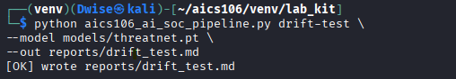

Data Drift
Data drift occurs when the characteristics of network traffic change over time.
Examples include:
- New business applications generating different traffic patterns.
- Changes in employee working practices (for example, remote work).
- Deployment of new cloud services.
- Operating system or software updates.
- Emerging attack techniques not represented in the training dataset.

Recommended Monitoring
- Monitor prediction confidence over time.
- Track Macro F1-score using newly labeled validation data.
- Review false-positive and false-negative trends.
- Schedule periodic model retraining.

General Adversarial Considerations
Attackers may attempt to reduce the effectiveness of behavioral detection systems by changing how their activity appears in network telemetry. Examples include:
- Performing malicious actions more slowly to resemble normal user activity.
- Distributing activity across multiple hosts or accounts.
- Using legitimate services or protocols to blend with normal traffic.
- Varying timing and communication patterns to avoid consistent behavioral signatures.
These examples illustrate why AI-based detection should be combined with layered security controls, continuous monitoring, and human analyst review.
Project Limitations
Limitation |  |  |  |  |  |  |  |  | Description
Synthetic Dataset |  |  |  |  |  |  |  |  | The model was trained and evaluated using synthetic telemetry, which may not capture all characteristics of production environments.
Limited Feature Set |  |  |  |  |  |  |  |  | Only network telemetry features were used; endpoint, identity, and threat intelligence data were not included.
Static Training |  |  |  |  |  |  |  |  | The model is not updated automatically after deployment.
Explainability Scope |  |  |  |  |  |  |  |  | Feature importance provides useful insight but does not fully explain every prediction.
Human Oversight Required |  |  |  |  |  |  |  |  | Predictions should support analyst decisions rather than replace them.

Interpretation
The Deep Residual ThreatNet model demonstrated strong performance in a laboratory environment, but its effectiveness may decrease as enterprise network behavior evolves. The drift test illustrates the need for ongoing monitoring and periodic retraining to maintain reliable detection performance. Operational deployment should include governance processes, analyst review, and validation on representative production traffic.

Deployment Recommendation
The objective of this section is to evaluate whether the Deep Residual ThreatNet model is suitable for deployment based on its training results, evaluation metrics, explainability, live demonstration, and risk assessment. The recommendation considers both the strengths and limitations of the model and outlines the controls that should be in place before operational use.

Deployment Assessment
The model was evaluated using a synthetic enterprise network telemetry dataset containing 30,000 events across six traffic classes. It demonstrated strong performance during laboratory testing, achieving high classification accuracy and balanced detection across multiple attack categories. The model also generated explainable predictions and successfully processed live streaming events during the demonstration.

References
The implementation of the Deep Learning for Threat Detection practical laboratory relied on established machine learning frameworks, cybersecurity concepts, and Linux-based tools. The following references were consulted during the design, implementation, evaluation, and documentation of the project.
Abadi, M., Agarwal, A., Barham, P., Brevdo, E., Chen, Z., Citro, C., Corrado, G. S., Davis, A., Dean, J., Devin, M., Ghemawat, S., Goodfellow, I., Harp, A., Irving, G., Isard, M., Jia, Y., Jozefowicz, R., Kaiser, Ł., Kudlur, M., ... Zheng, X. (2016).

Chollet, F. (2021). Deep learning with Python (2nd ed.
Python Software Foundation. (2024). Python documentation. https://docs.python.org/3/
TensorFlow Developers. (2024). TensorFlow documentation. https://www.tensorflow.org/
The pandas Development Team. (2024). pandas documentation. https://pandas.pydata.org/
The Linux Foundation. (2024). Linux documentation. https://www.kernel.org/doc/
VMware, Inc. (2024). VMware Workstation documentation. https://docs.vmware.com/
MITRE Corporation. (2024). MITRE ATT&CK Framework. https://attack.mitre.org/
Evidence Included in the Practical Report
Evidence | Description | Interpretation

Linux terminal screenshots | Dataset loading,  model execution,  and prediction commands. | Demonstrates successful execution of the practical tasks.

Model training output | Training and validation accuracy/loss for each epoch | Confirms that the model learned effectively without significant overfitting.

Confusion matrix | Classification results for all traffic classes | Shows high detection accuracy and balanced classification performance.

Classification report | Precision, Recall, and F1-score | Indicates reliable detection across all attack categories.

SHAP explainability plots | Feature importance for model predictions | Demonstrates transparency and supports analyst interpretation of alerts.

Live dashboard screenshots | Real-time prediction of streaming network events | Verifies that the deployed model can process live traffic successfully.

Risk assessment summary | Identified deployment risks and mitigation strategies | Supports the recommendation for phased deployment with continuous monitoring.

